Project Based Experiential Learning
Optimizing User, Group, and Role Management with Access Control and Workflows
Team ID : NM2025TMID02199
Team Size : 4
Team Leader : Daniel Jabaraj V
Team member : Domik RAJ K
Team member : Sriram D
Team member : Durga M
📘 Project Documentation
Title: Optimizing User, Group, and Role Management with Access Control and Workflows
Platform: ServiceNow
Methodology: Project-Based Experiential Learning
Category: ServiceNow System Administartor
Skills Required:
Tensorflow,Oracle DB

🧩 Problem Statement
In a compact project team comprising:
- 👩‍💼 Alice – Project Manager
- 👨‍🔧 Bob – Team Member
…there exists a critical need to streamline task management and ensure accountability. The current system lacks:
- 🔒 Defined roles and access controls
- 🧑‍🤝‍🧑 Structured group management
- 🔄 Automated workflows for task tracking
This leads to confusion, inefficiencies, and poor visibility across the project lifecycle.
🎯 Project Objectives
✅ Establish clear user roles and permissions
✅ Implement group-based access control
✅ Design structured workflows for task lifecycle
✅ Enhance transparency and accountability

👥 Stakeholder Matrix
Role | Name | Responsibilities
👩‍💼 Project Manager | Alice | Assign tasks, review progress, approve completions
👨‍🔧 Team Member | Bob | Execute tasks, update status, report blockers

🛠️ Key Components & Steps

1. 👤 Users
Purpose: Represent individuals in the system.
Steps:
- Create user profiles with unique identifiers (e.g., username, email)
- Assign basic attributes (name, role, department)
- Link users to groups and roles
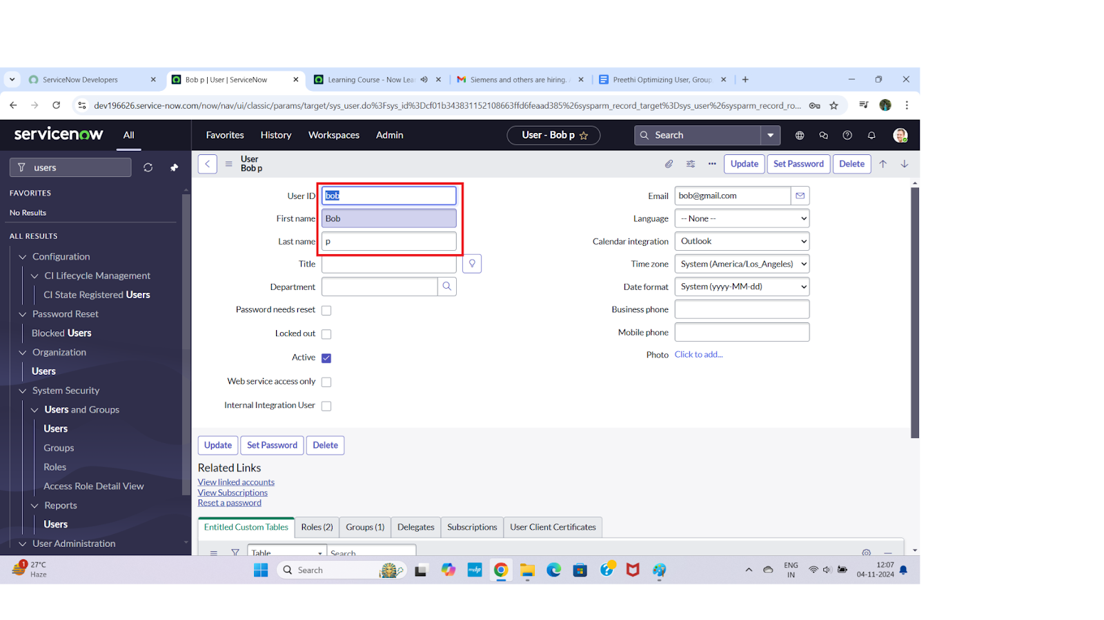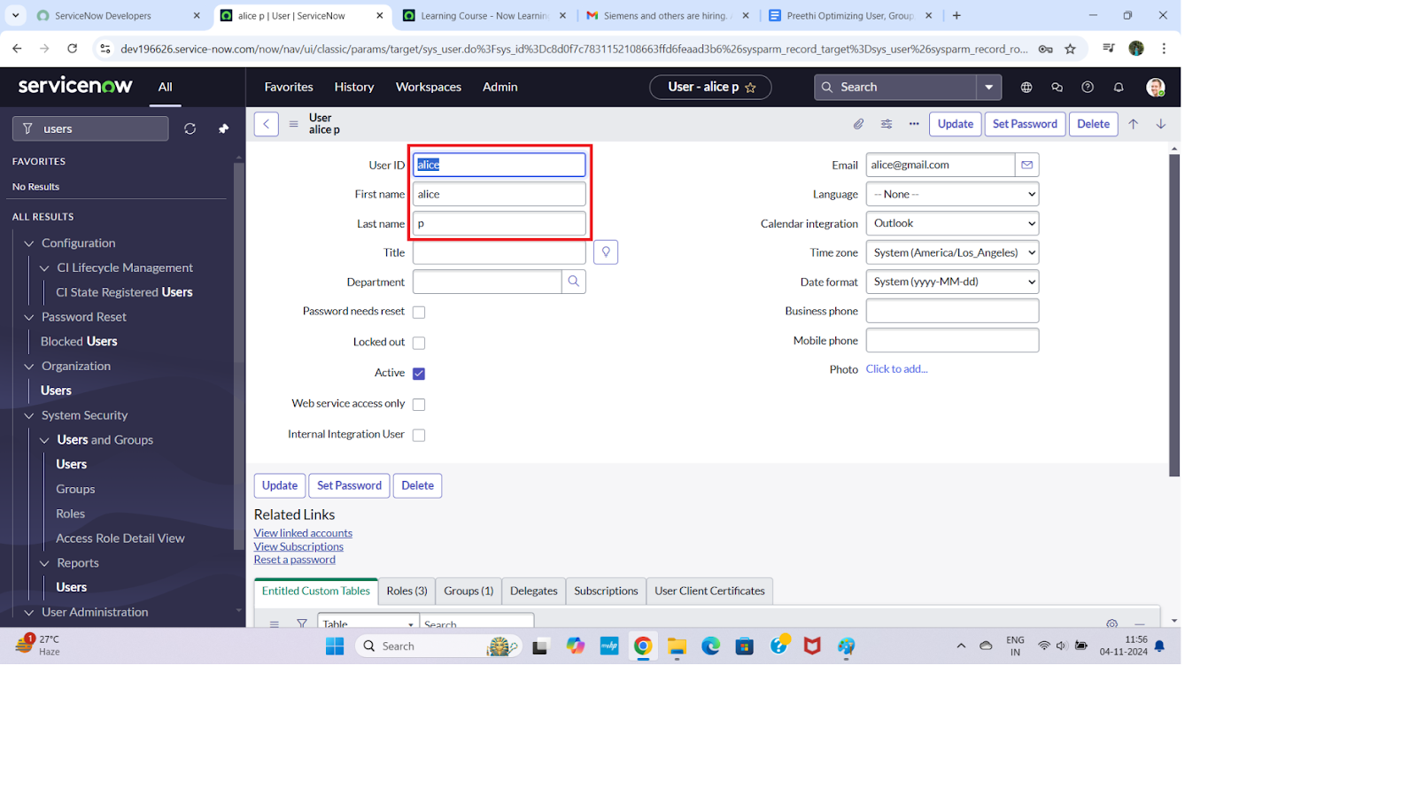

2. 👥 Groups
Purpose: Logical collections of users for simplified permission management.
Steps:
- Define group categories (e.g., Development, QA, Management)
- Add users to appropriate groups based on responsibilities
- Ensure groups reflect organizational structure
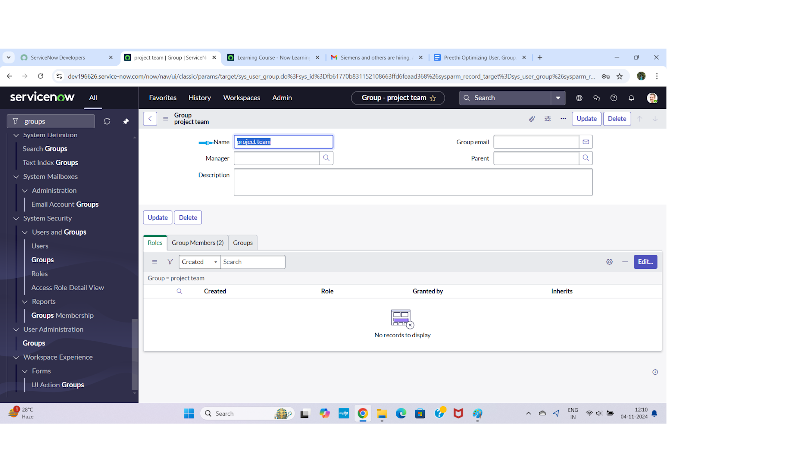

3. 🧑‍💼 Roles
Purpose: Define access levels and responsibilities.
Steps:
- Identify key roles (e.g., Project Manager, Developer, QA Tester)
- Assign permissions to each role (read, write, execute)
- Map roles to users or groups
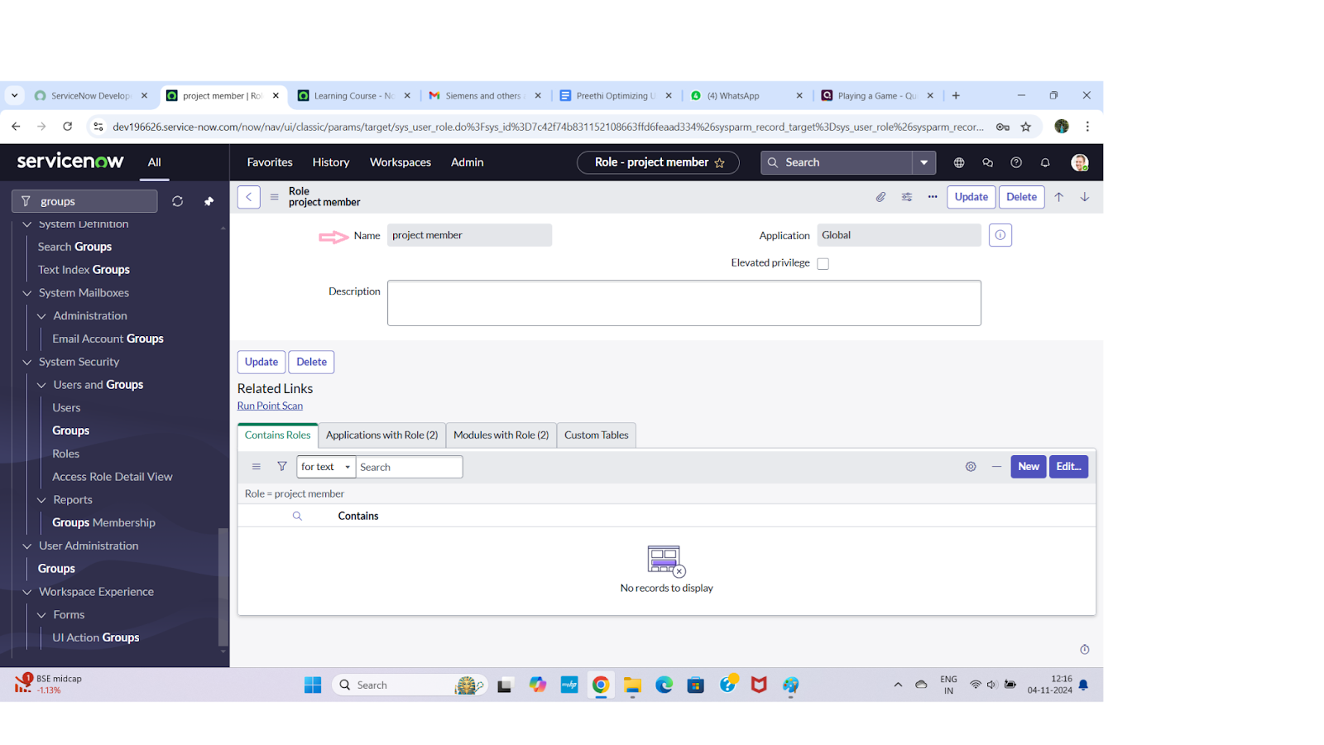

4. 🔗 Assign Users to Groups
Purpose: Enable scalable and manageable access control.
Steps:
- Match users to relevant groups based on their job function
- Review group membership periodically
- Automate group assignment if possible (e.g., via onboarding workflow)
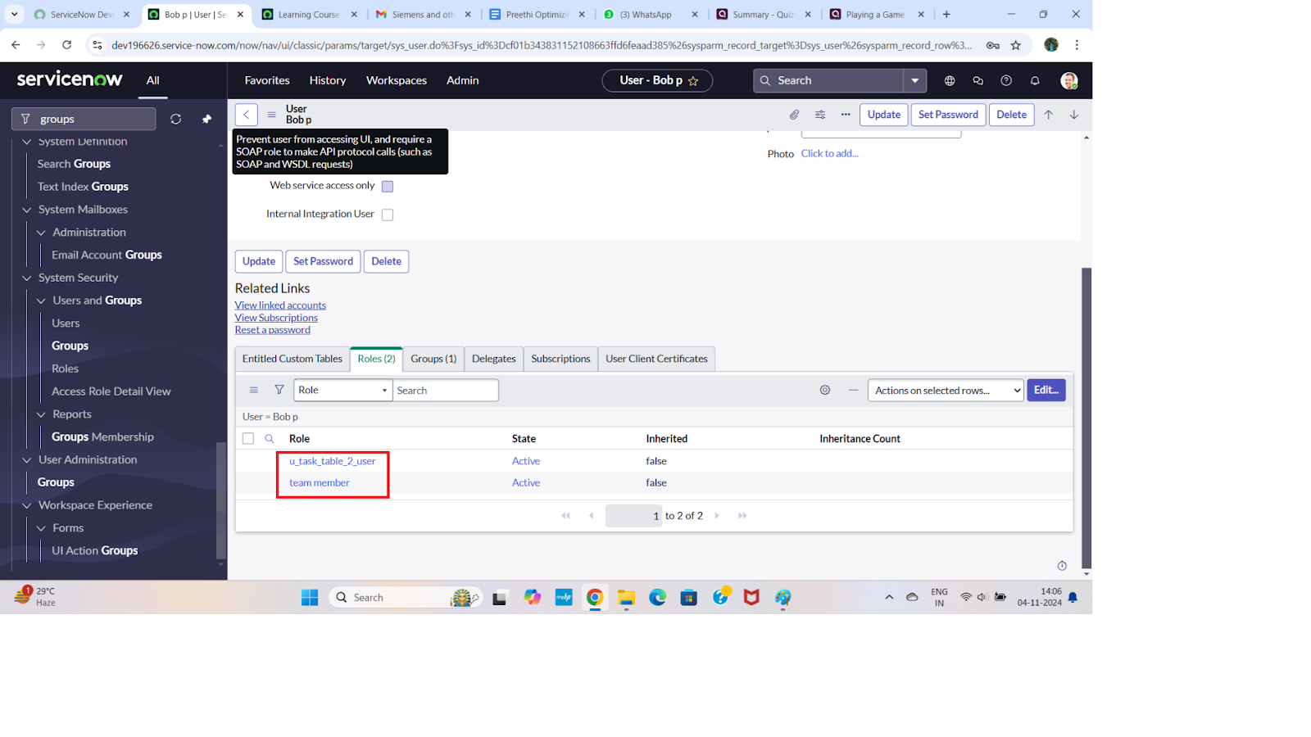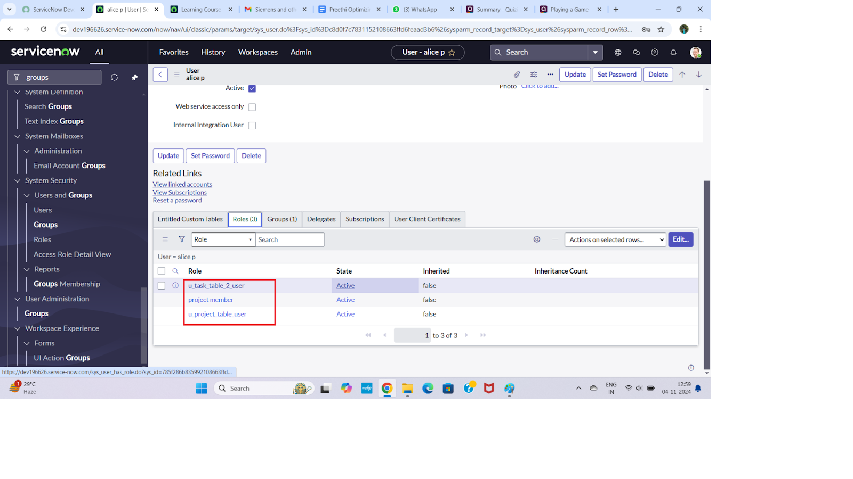

5. 🗂️ Application Access
Purpose: Control access to specific applications or modules.
Steps:
- Define access rules per application
- Link applications to roles/groups
- Monitor and audit access logs
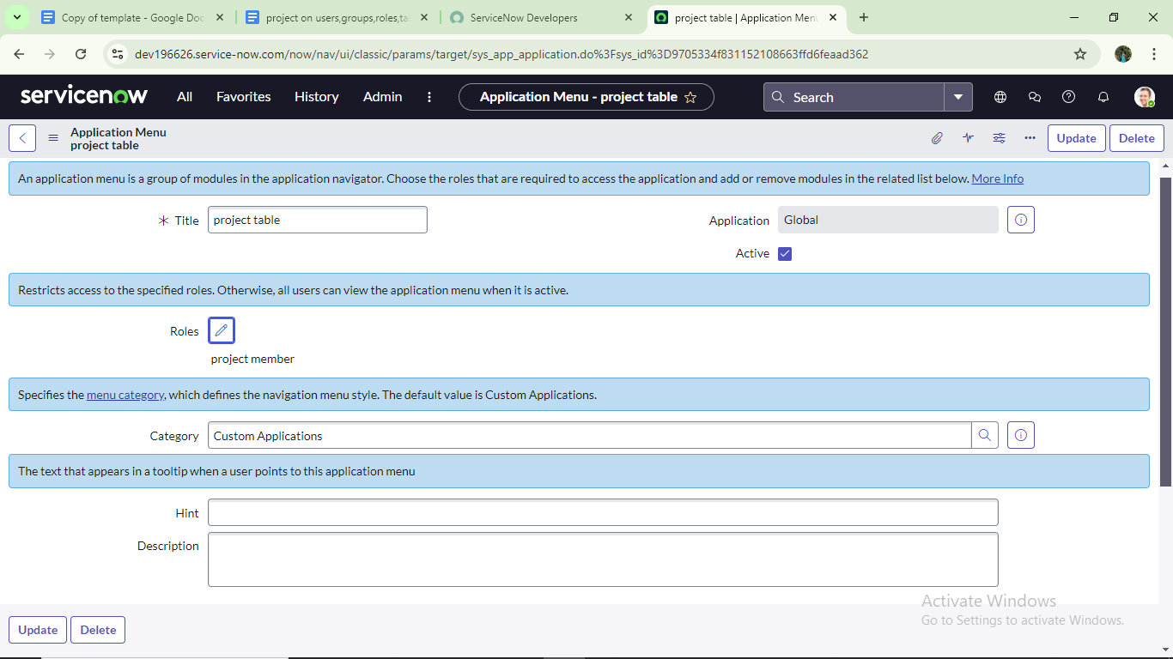
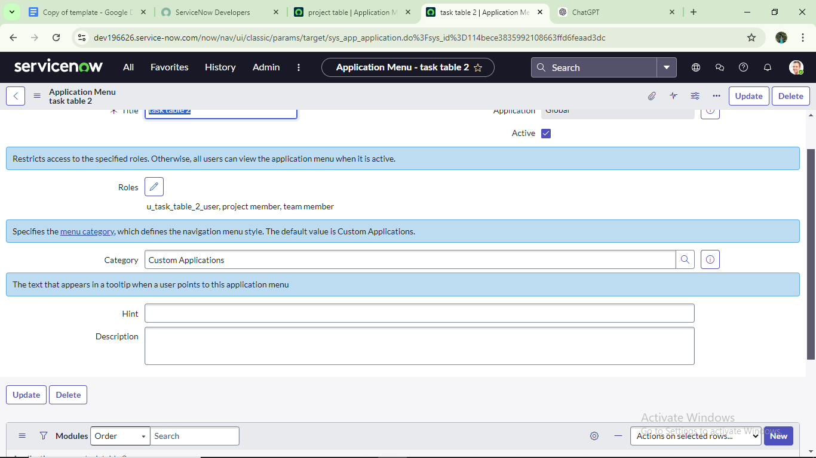

6. 🔐 Access Control List (ACL)
Purpose: Specify permissions for users and groups.
Steps:
- Create ACL entries for each resource (e.g., files, modules)
- Assign read/write/execute permissions
- Enforce ACLs during user actions
- Log access attempts for auditing
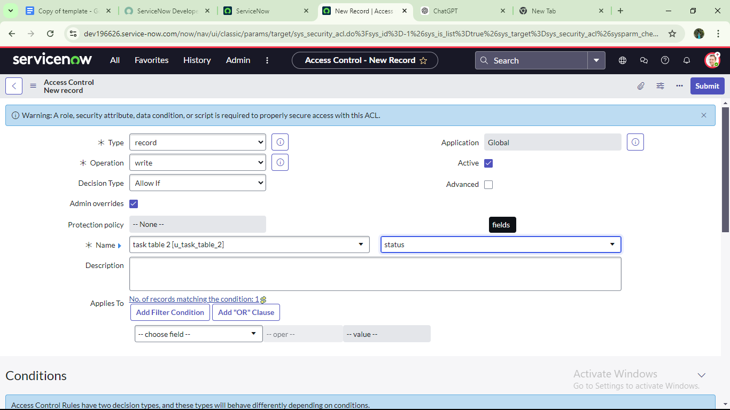
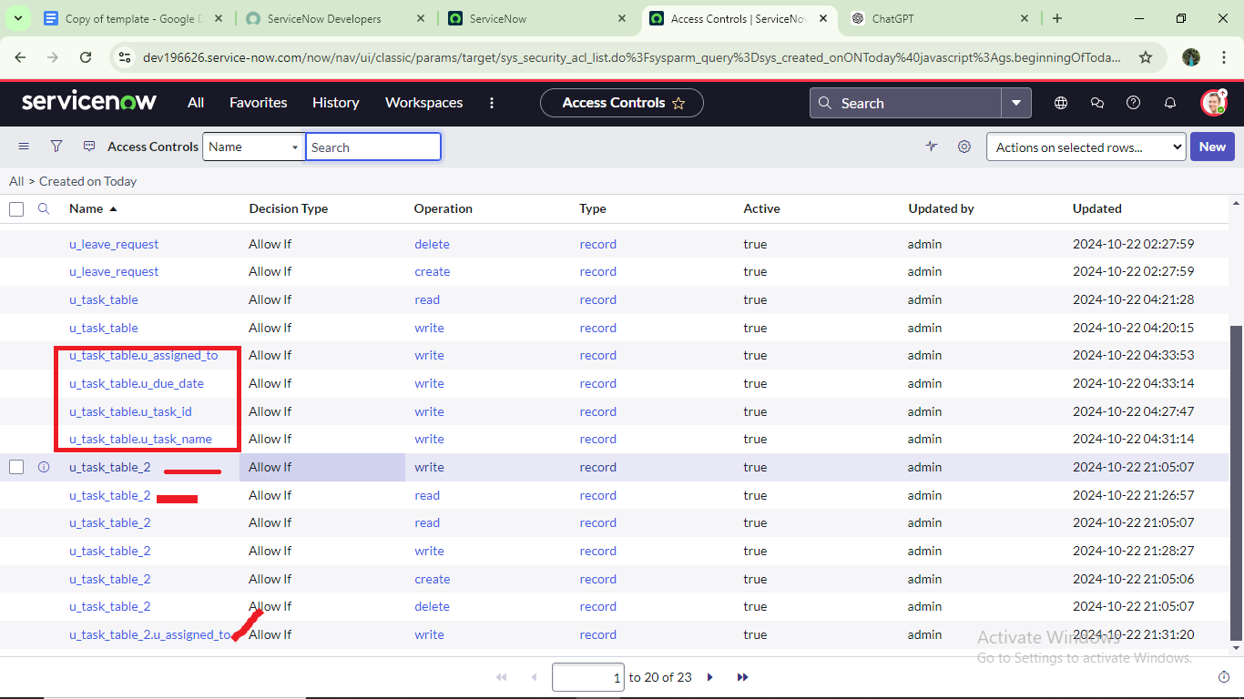

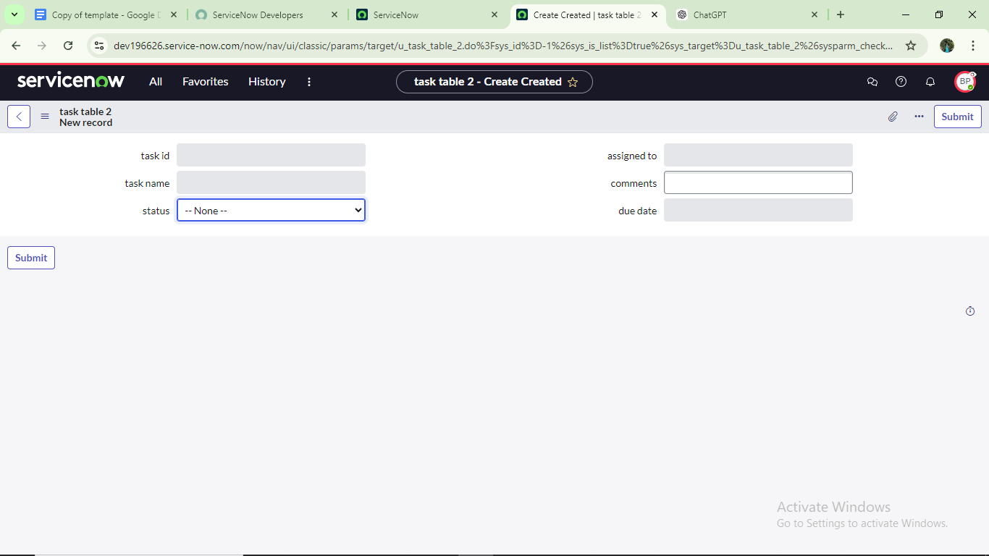

7. 🔄 Workflow
Purpose: Structure task assignment and tracking.
Steps:
- Define workflow stages (e.g., To Do → In Progress → Review → Done)
- Assign tasks to users based on roles
- Track progress and update status
- Notify stakeholders of changes or delays
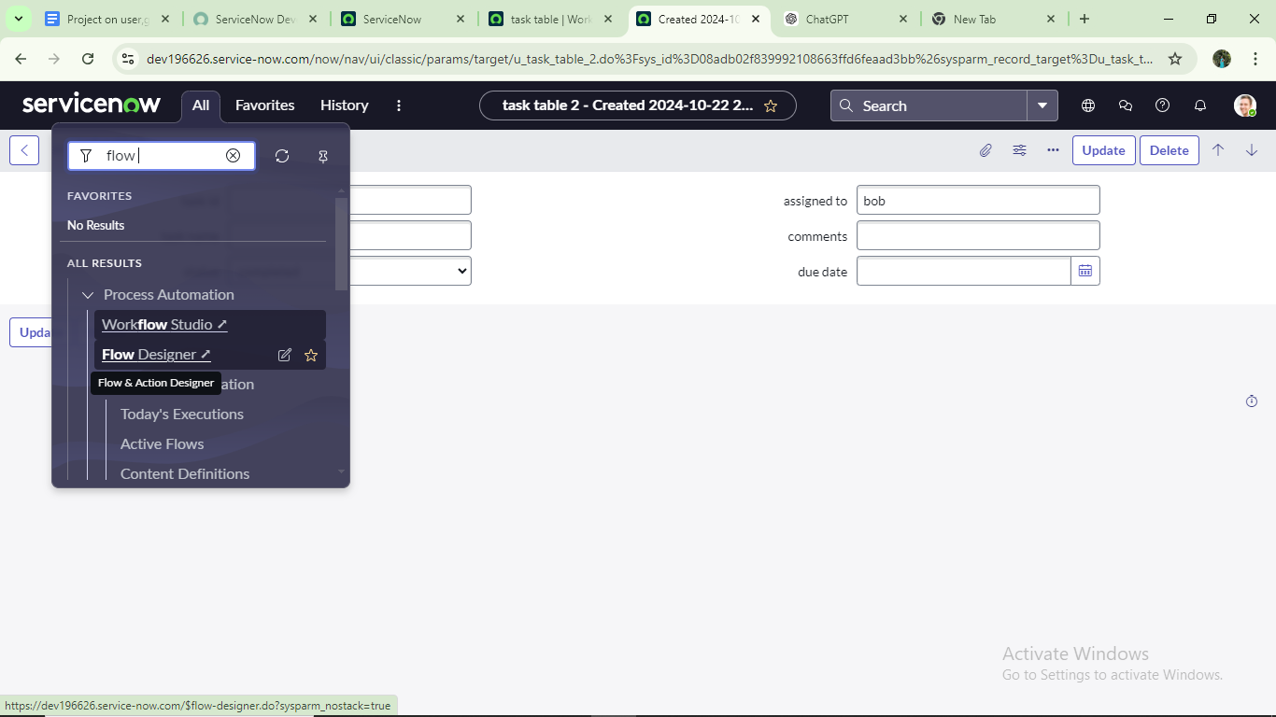
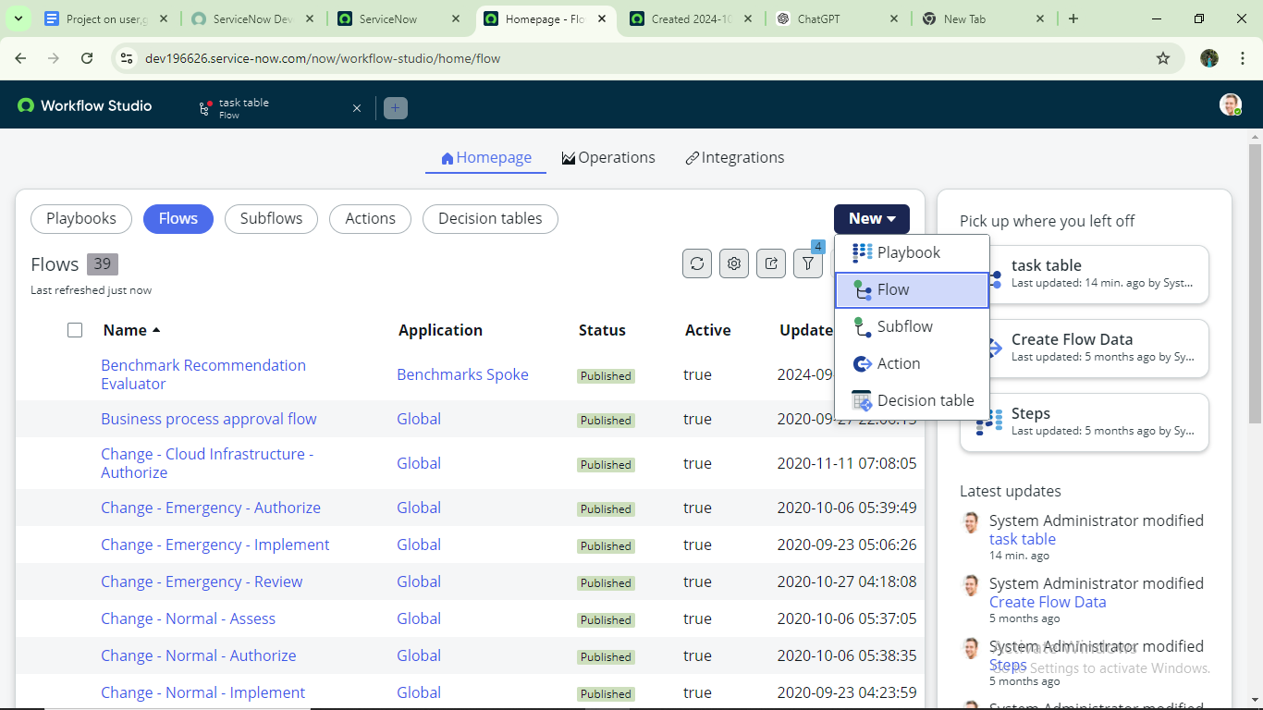
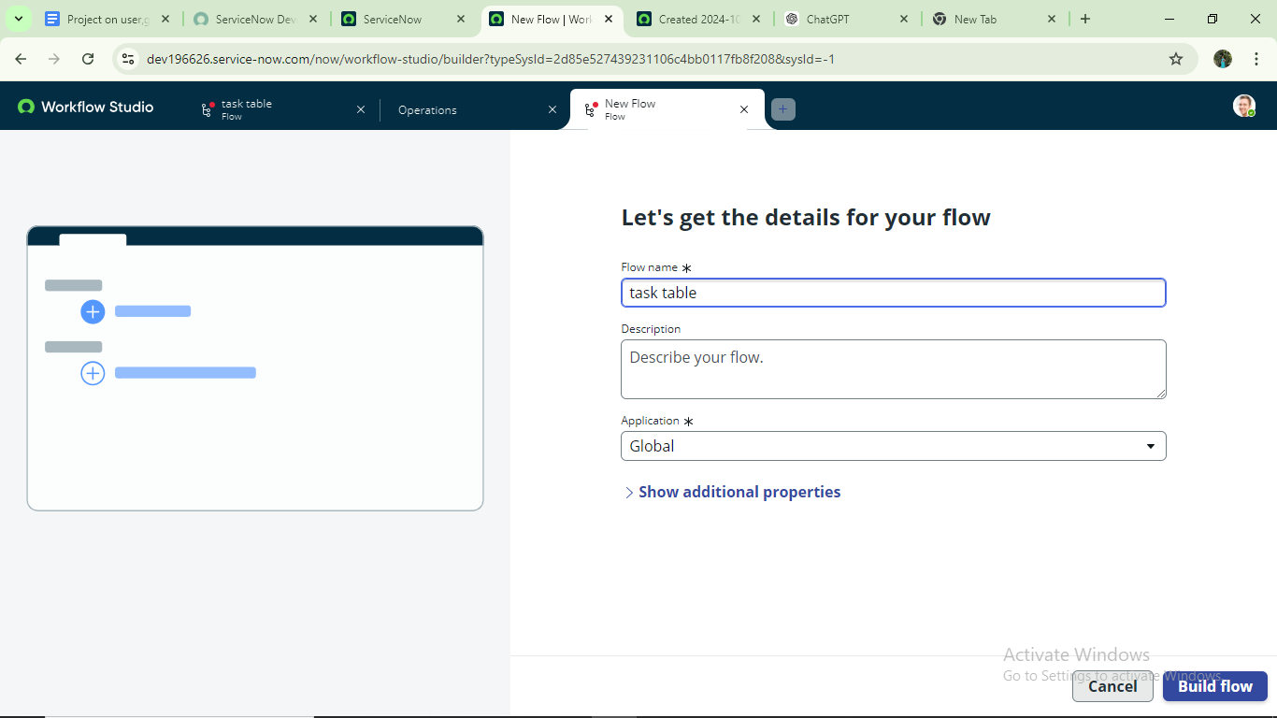
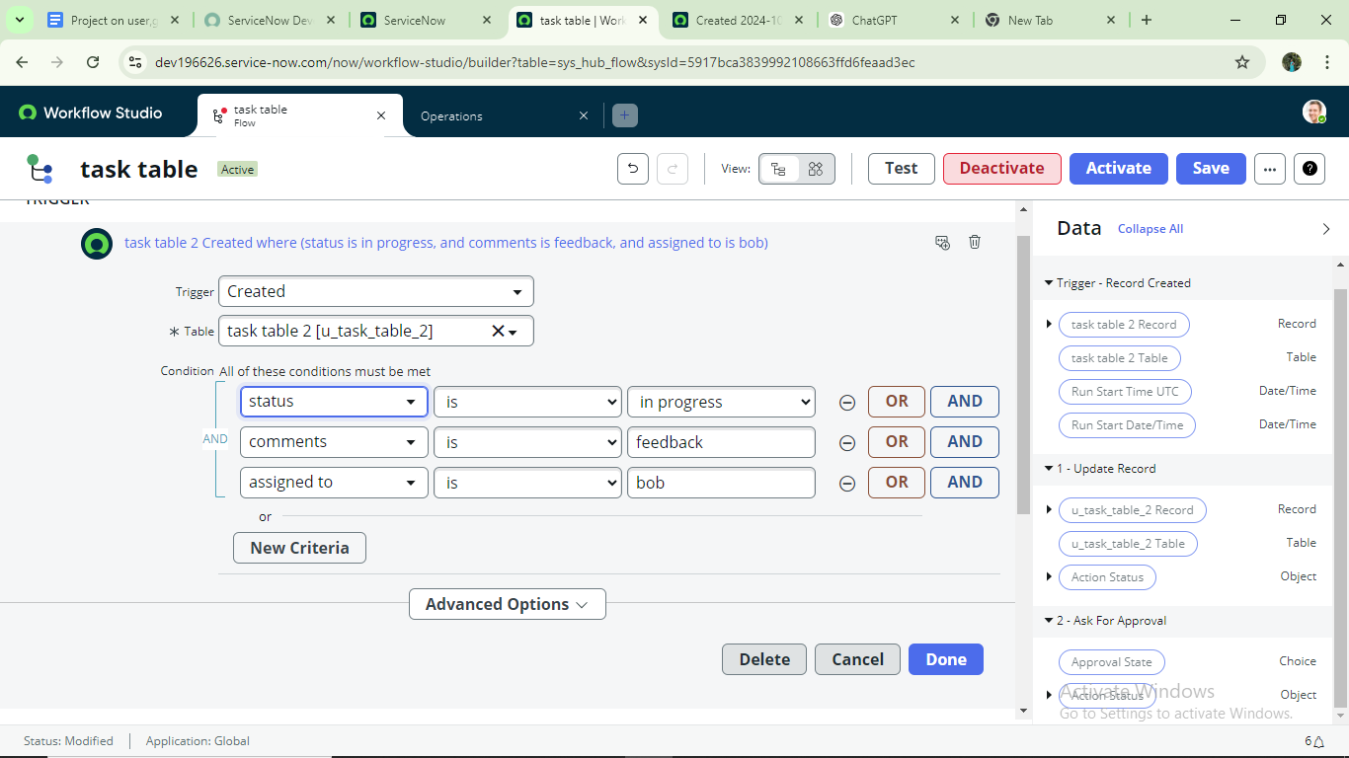
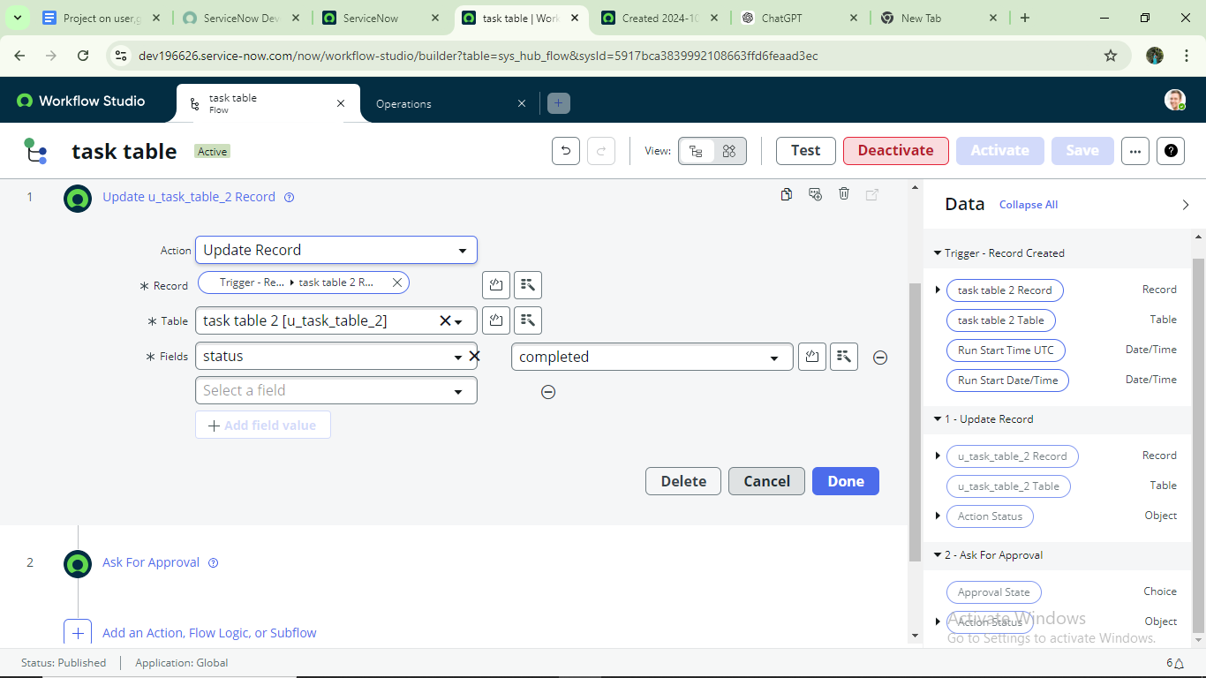
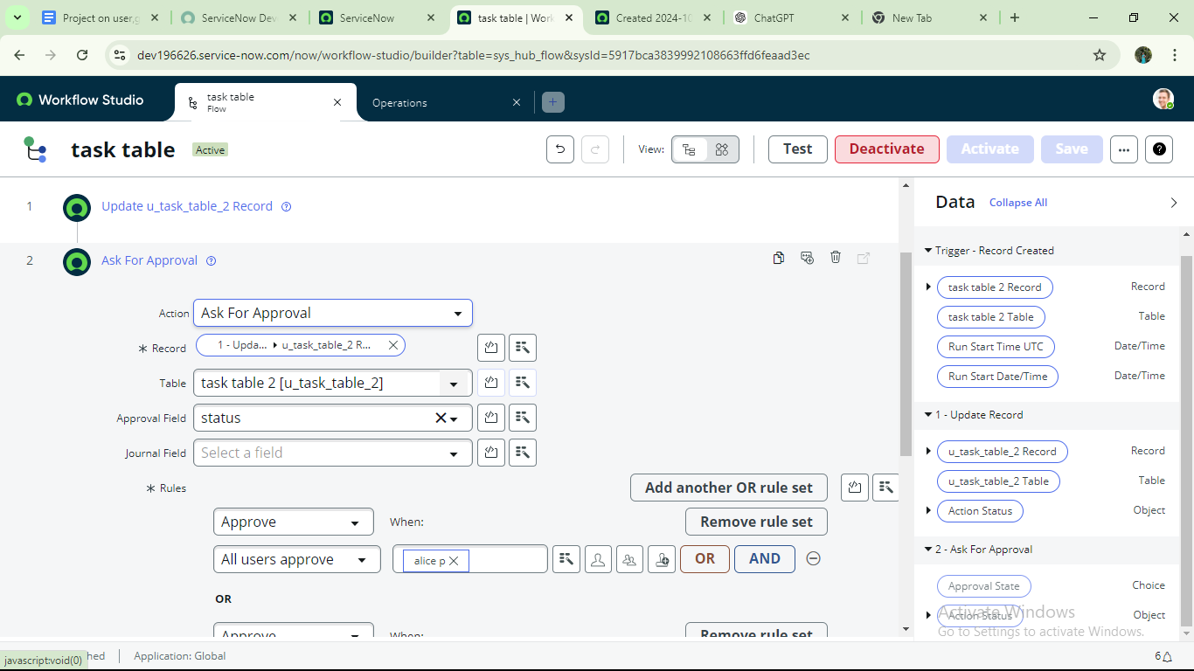
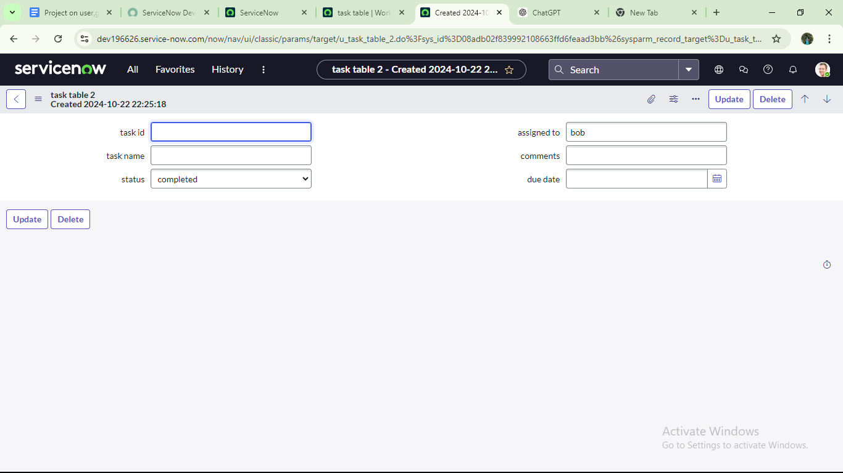
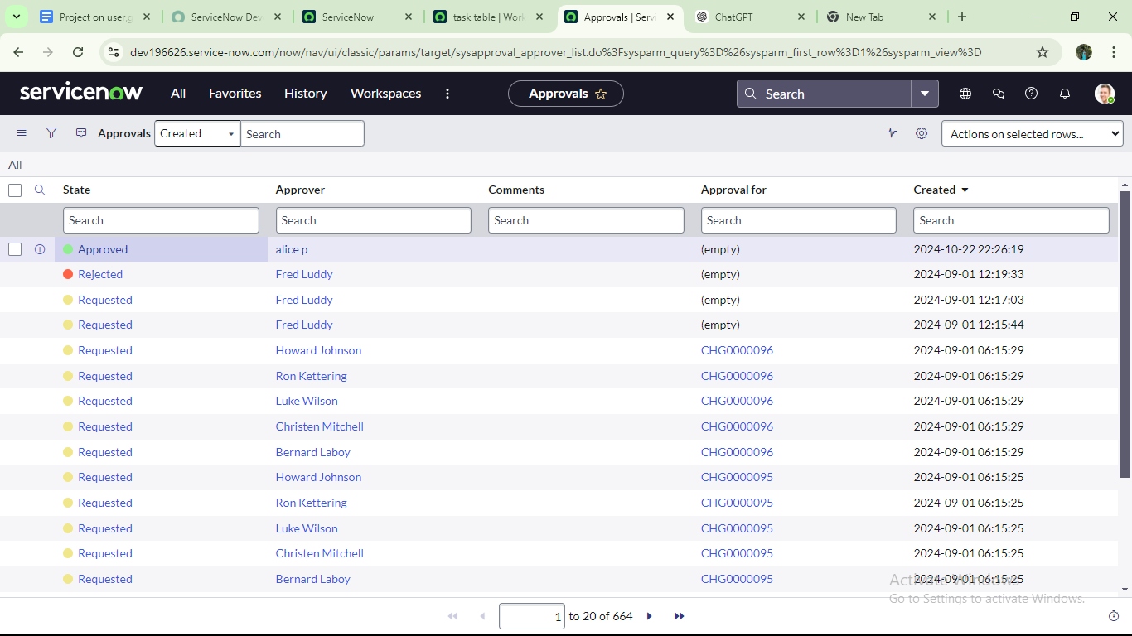
📈 Benefits
✨ Role-based access improves data security
✨ Group management simplifies administration
✨ Automated workflows reduce manual effort
✨ Audit trails boost accountability

Conclusion :
This scenario highlights a structured approach to project management, showcasing the roles of Alice and Bob within a defined workflow. With Alice's oversight and Bob's execution, the team effectively collaborates to ensure project success. The use of tables organizes key information, facilitating easy tracking of projects, tasks, and progress updates. Overall, this system promotes accountability, enhances communication, and leads to the successful completion of projects.

